Estrogen data set analysis preamble

In order to introduce you to affylmGUI we will make use of a prepared tutorial put together by its developers. The web site for this tutorial is at:
http://bioinf.wehi.edu.au/affylmGUI/R/library/affylmGUI/doc/estrogen/estrogen.html

The data set being used is a human one, where mRNA is gathered from ER+breast cancer cells which have been treated with estrogen and the samples are gathered 10 or 48 hours after treatment and equivalent controls have been gathered.

The tutorial will cover the various options possible with affylmGUI which can briefly be described as being either quality control checks on the data or tests to find what genes are differentially expressed, namely what genes have undergone a statistically significant change in their expression levels between the different sample types. Once you have completed reproducing the analysis, you can then move on to analysing the Rubber data set, and reproduce the same type of analysis carried out here.

Before getting started, there are a few points to be made:

- There is a section at the start of the tutorial marked REQUIREMENTS FOR RUNNING affylmGUI; since we have already gone through the installation of the relevant packages to run affylmGUI it is not necessary to execute these commands. You can start from where the package is started where you type > library(affylmGUI)
- Because of a recent rearrangment at the bioconductor site, the estrogen data set cannot be downloaded from the link provided in the tutorial. You can download a zip file with the data from
http://gene.cs.rhul.ac.uk/CCC10/estrogen.zip

once you have downloaded the zip file, uncompress it and note where it is stored. It contains the raw CEL files for the data and the “targets” file which is necessary to identify the differentially expressed genes.

- In the latest version of affylmGUI there has been a reorganisation of the different types of multiple test correction algorithms that are available. In the new version, BH is equivalent to what was described as FDR in the tutorial. Use this option.
- Once you are familiar with generating a list of differentially expressed genes, regenerate a list for all of the genes and store the resulting data in a file (you can do this by clicking on File in the top left corner of the resulting window). We will make use of this file when we want to do the Gene Ontology analysis.
- You can ignore the section at the end on Probe-Level Linear Model Normalization.

ClueGO analysis of differentially expressed estrogen data set genes

One clear problem in analysing transcriptomic data is that we are usually presented with a list of 100’s of genes that are clearly differentially expressed in a particular experiment. The question now is what biological conclusions can we draw from this data ? The most widely used approach (apart from simply going through the list and examining each gene one by one) is to ask if particular categories of genes occur more than one would expect. The plugin ClueGO (which is used within Cytoscape) allows you to do this. In this part of the tutorial we will perform this type of analysis on a set of genes that were found to be differentially expressed in the estrogen data set.

- In the previous part of the tutorial, you should have saved the table of differentially expressed genes from affylmGUI. This table should have all the genes in the human genome listed. This file should be stored as a text file. We will import this into Excel and select a subset of genes from them. Start Excel.
- Click on “Data”, “Import External Data”, “Import Data”.
- Select the file you saved in affylmGUI.
- Using the text import wizard, import the file into Excel.
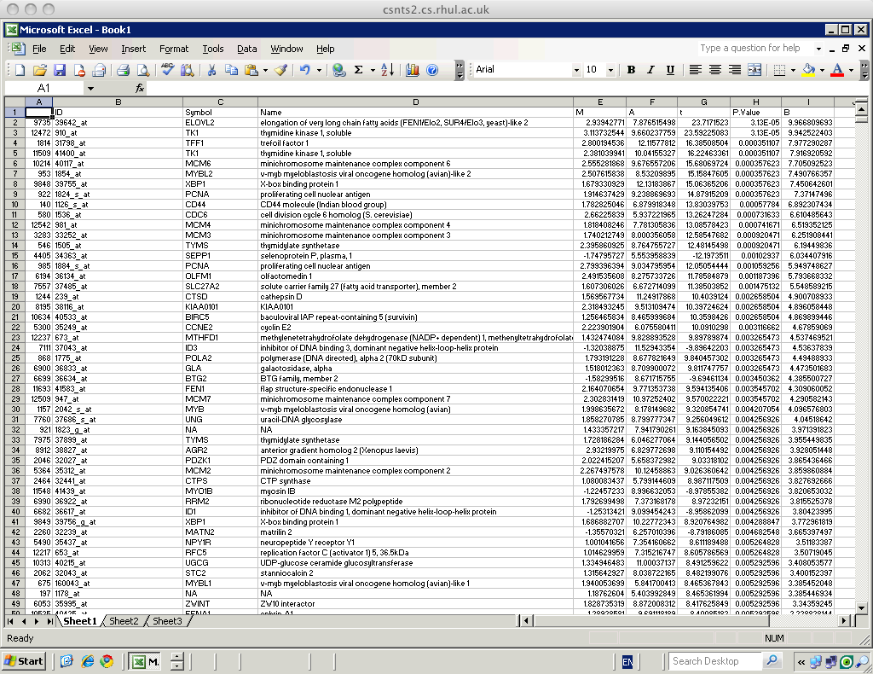

- You will see that the gene names are listed in order of the parameters t, P-value or B. Find all the genes that have a P-value which is less than 0.05 (i.e. all the genes where the probability that genes are not differentially expressed is less than 0.05). Select the Symbol Names of these genes and copy them into a new spreadsheet.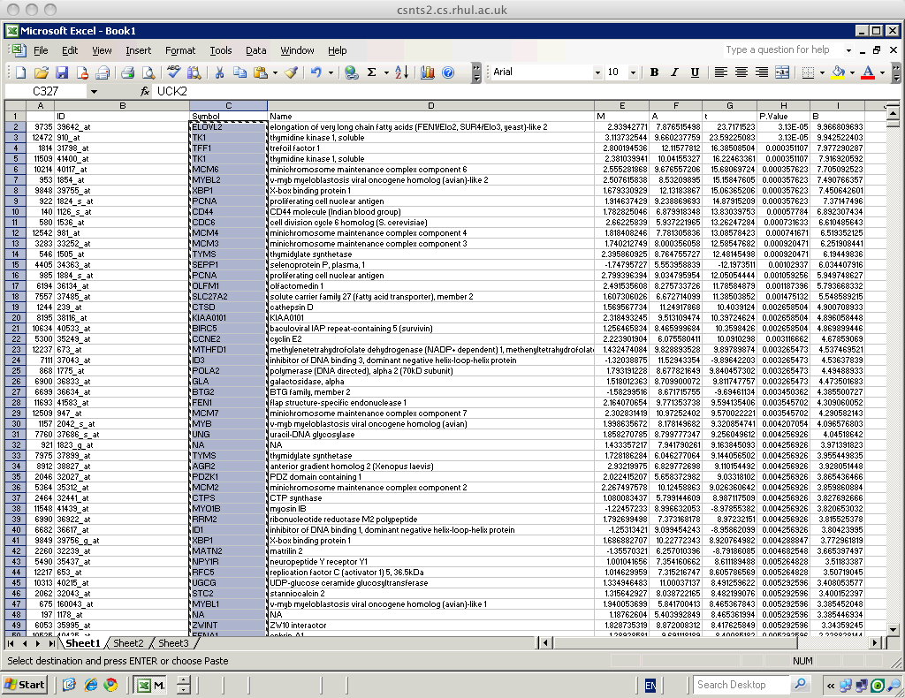

- Store this new spreadsheet. Do not store it as a standard spreadsheet. Store the file as a “tsv” file (i.e. as a text file). This is the format that Cytoscape and ClueGO can read.
- Close Excel. Start Cytoscape and start ClueGO from the plugins menu.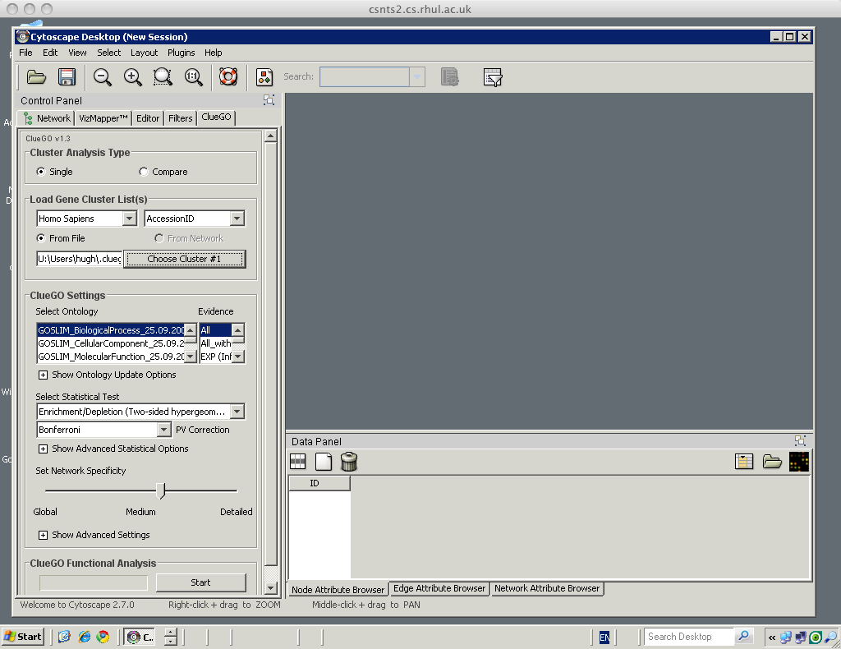
- In the “Load Gene Cluster Lists(s)” section, leave the species as Homo sapiens and select SymboID from the list beside it.
- Click on the “Choose Cluster #1” button and select the text file of the gene names you selected.
- In the “Select Ontology” selection, pick “GO_BiologicalProcess_20_10_2008”. This means that terms associated with Biological Processes are considered here.
- In the section marked “Select Statistical Test”, select “Enrichment (Right-sided hypergeometric test)”. This means that terms which are over-represented will be listed.
- Move the slider in “Set Network Specificity” to “Global”.
- Click Start.
- When it is finished the analysis, click OK on the summary. You should get something that looks this.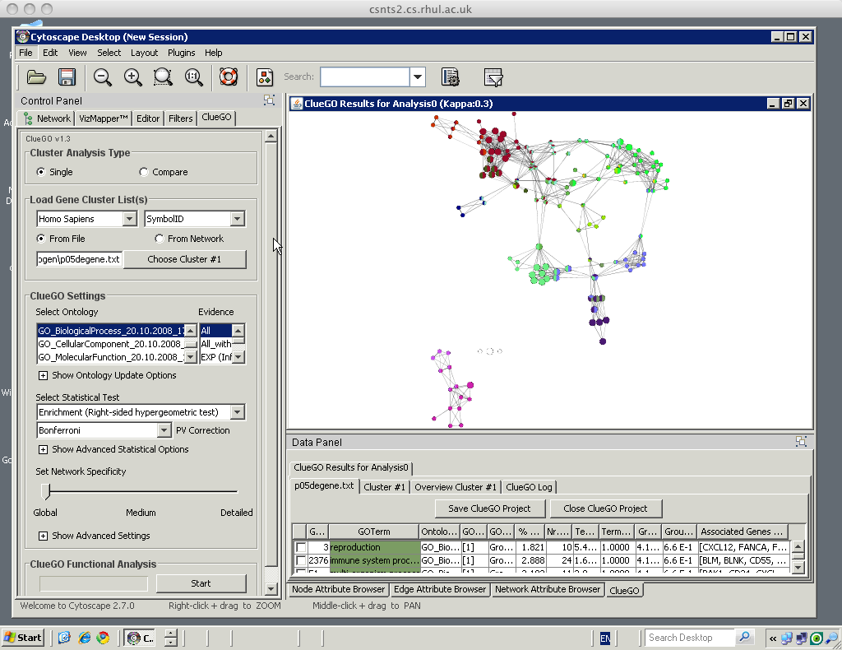
- Each node on the graph represent an over-represented term. Similar terms are grouped together. In the data panel you can see the terms and statistics associated with them.
- Select a cluster of nodes and click on icon with a magnifying glass to zoom into it. Here we’ve picked terms associated with localization. 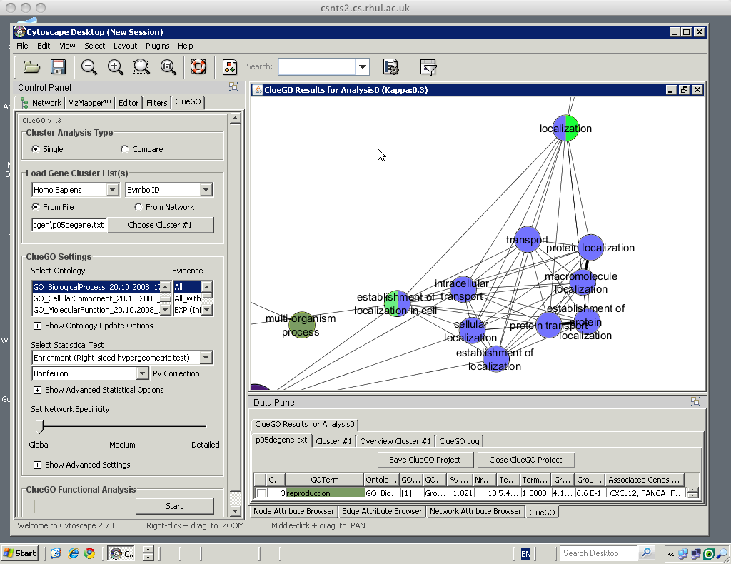
- You can adjust the network specificity section more if you wish by adjusting the slider but this will take much more time process even for a medium setting.

